Nama : Viona Paramitha

Kelas : 5C

NIM : 18090097

Praktikum 4

1. Source Code : web.php >>> application/controllers/

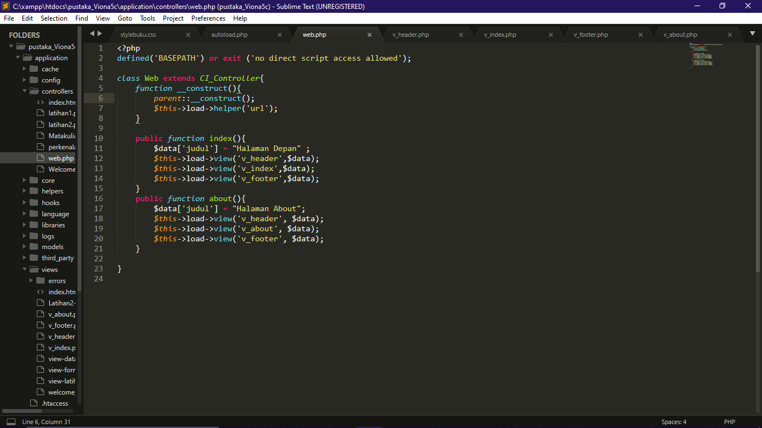

1. Source Code : v_header.php >>> application/views/

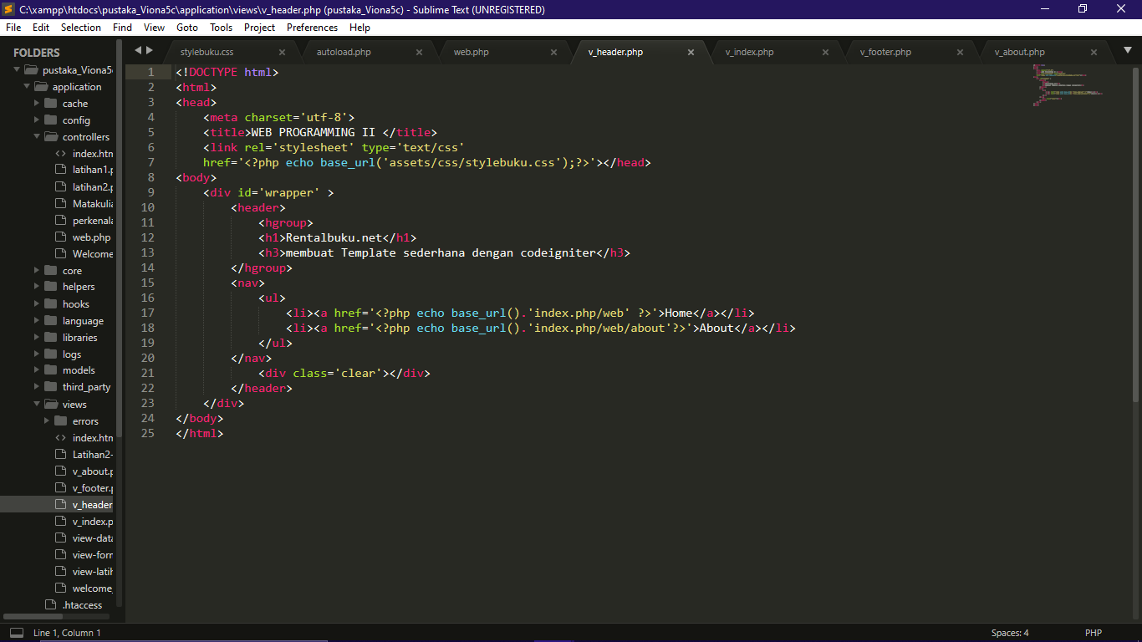

1. Source Code : v_index.php >>> application/views/

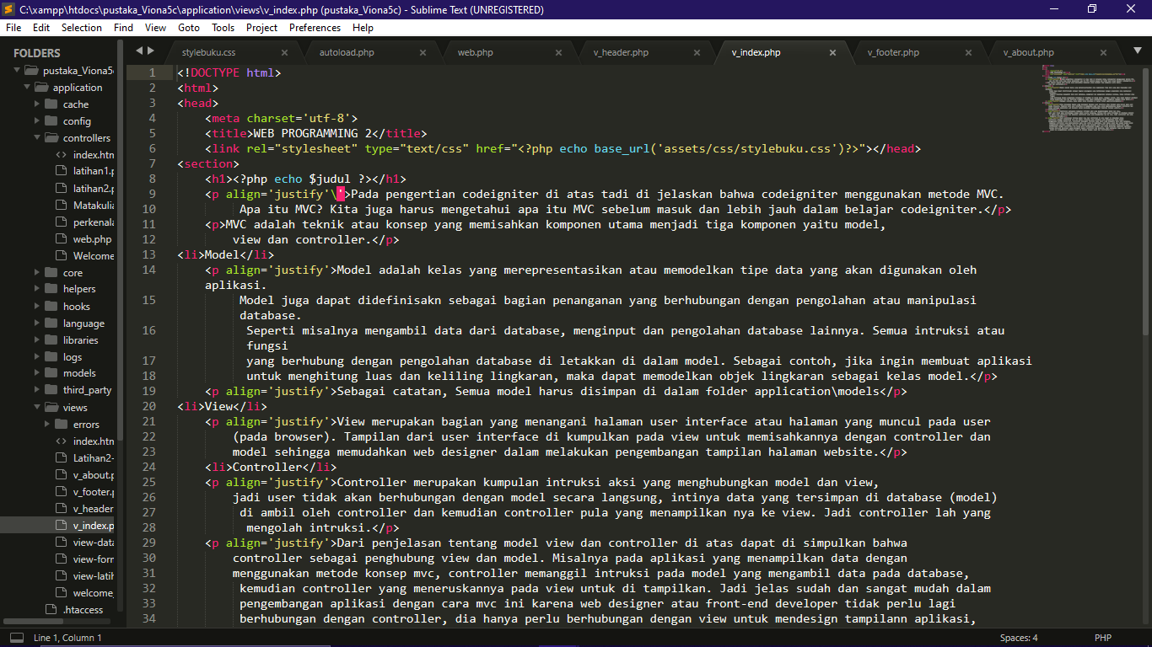

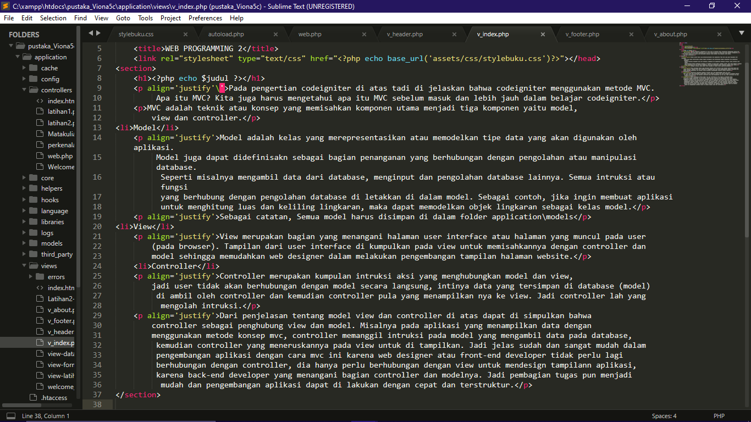

1. Source Code : v_footer >>> application/views/

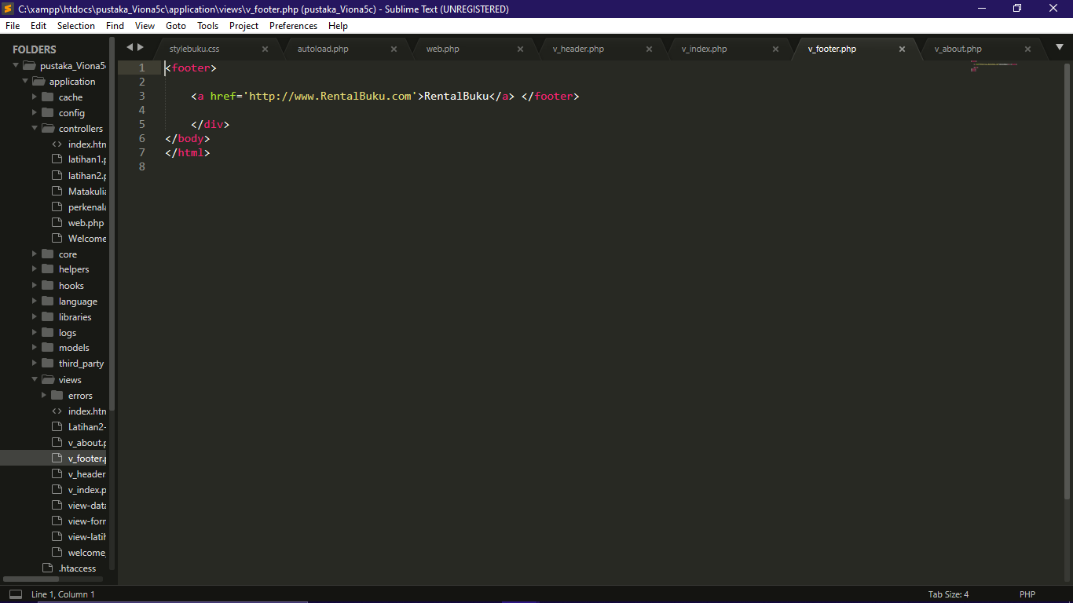

1. Source Code : stylebuku.css >>> assets/css/

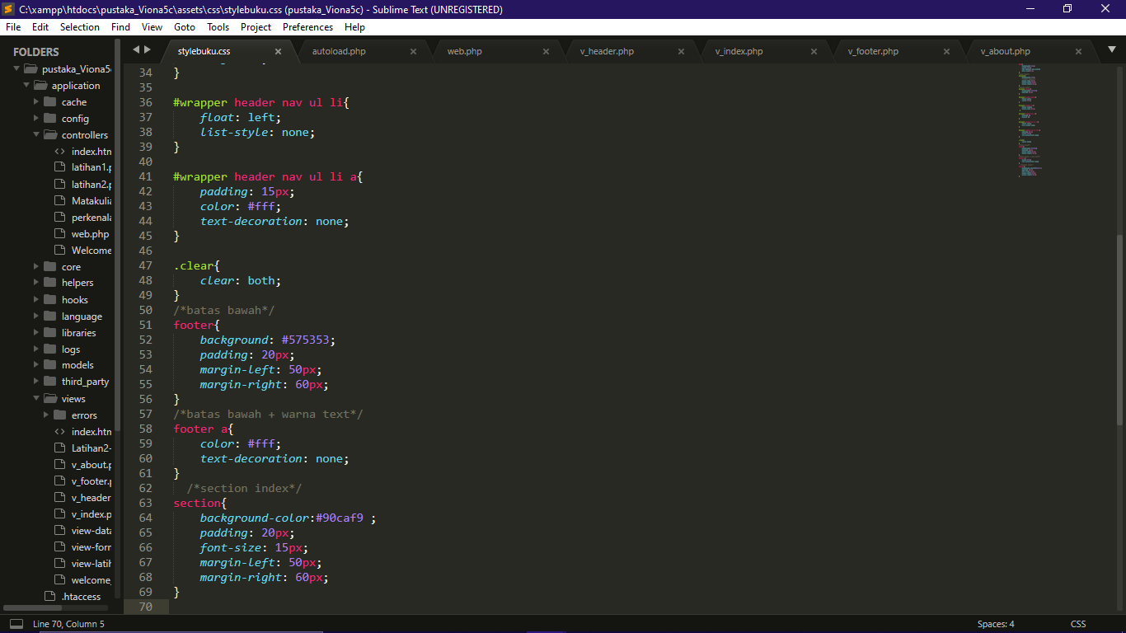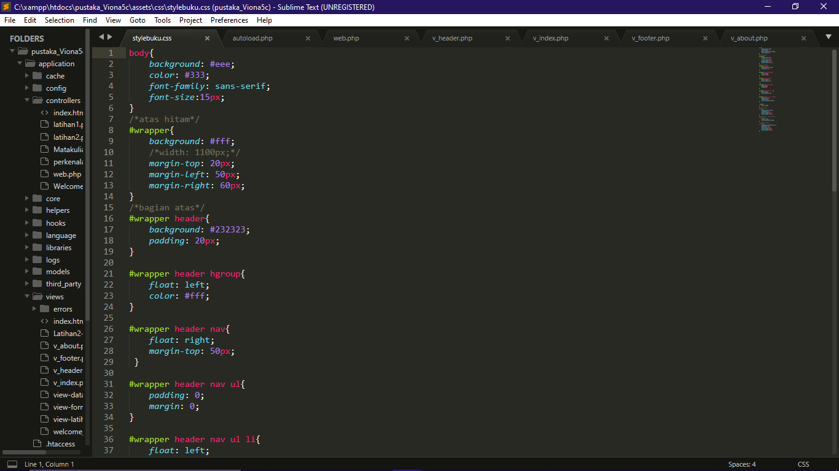

1. Source Code : config.php >>> application/config/

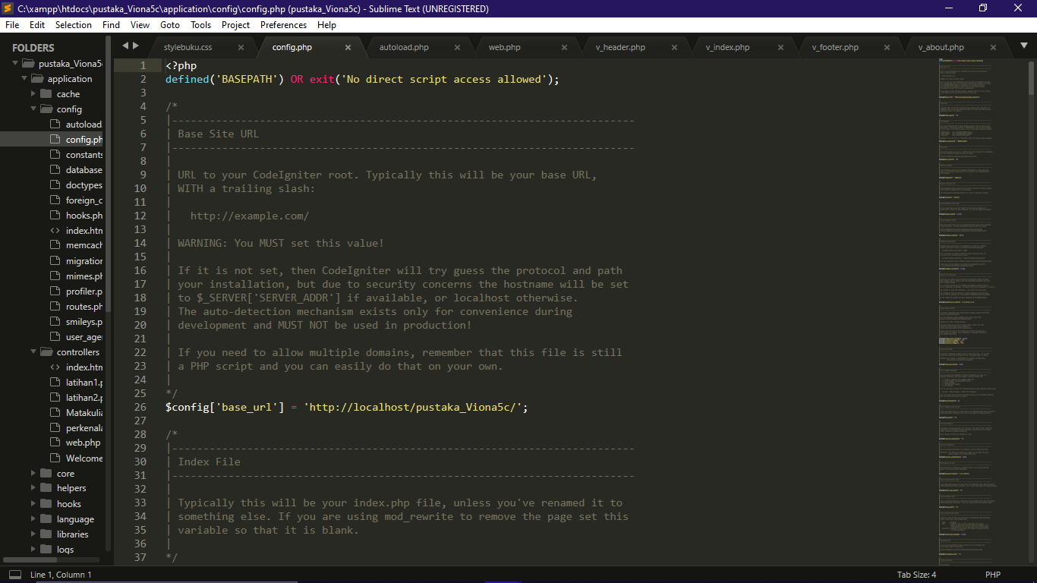

1. Source Code : autoload.php >>> application/config/

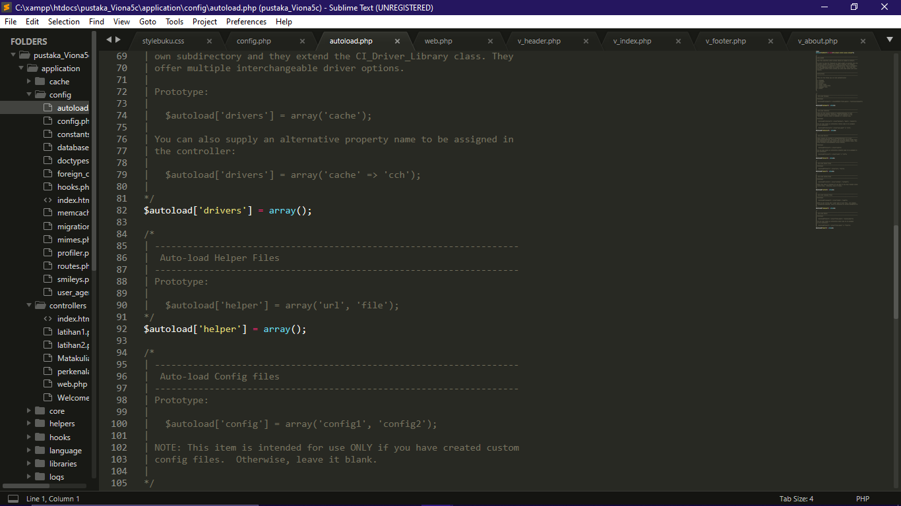

1. Source Code : v_about.php >>> application/views/

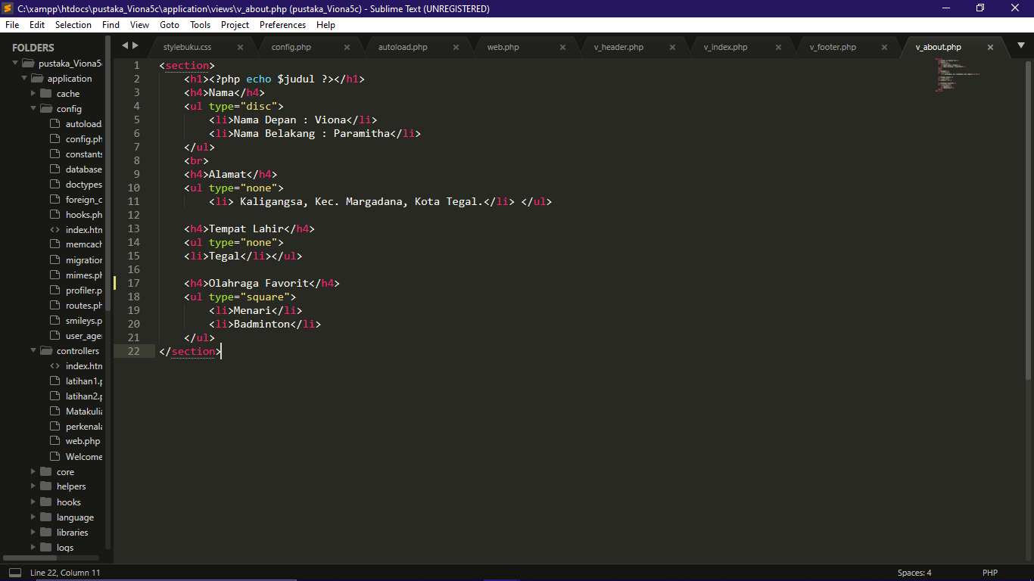

Hasil URL :

<http://localhost/pustaka_Viona5c/index.php/web>

<http://localhost/pustaka_Viona5c/index.php/web/about>

Capture Hasil :

